**Patient Data Management System**

**Team:**

BHAVIRISETTI CHANDRASEKHAR – 16344254

BATTULA RASI HARSHINI – 16341280

BOLLINENI SANDEEP SAI – 16345740

MUKTA HARINI - 16343090

**TECHNICAL UPDATE:**

Here is the technical update on the progress of our Patient Data Management System (PDMS) project over the last weeks

Key Achievements:

1. Completion of User Authentication System:

- The team successfully implemented a robust user authentication system using blockchain-based identity management. This ensures secure access to the PDMS, aligning with healthcare data security standards.

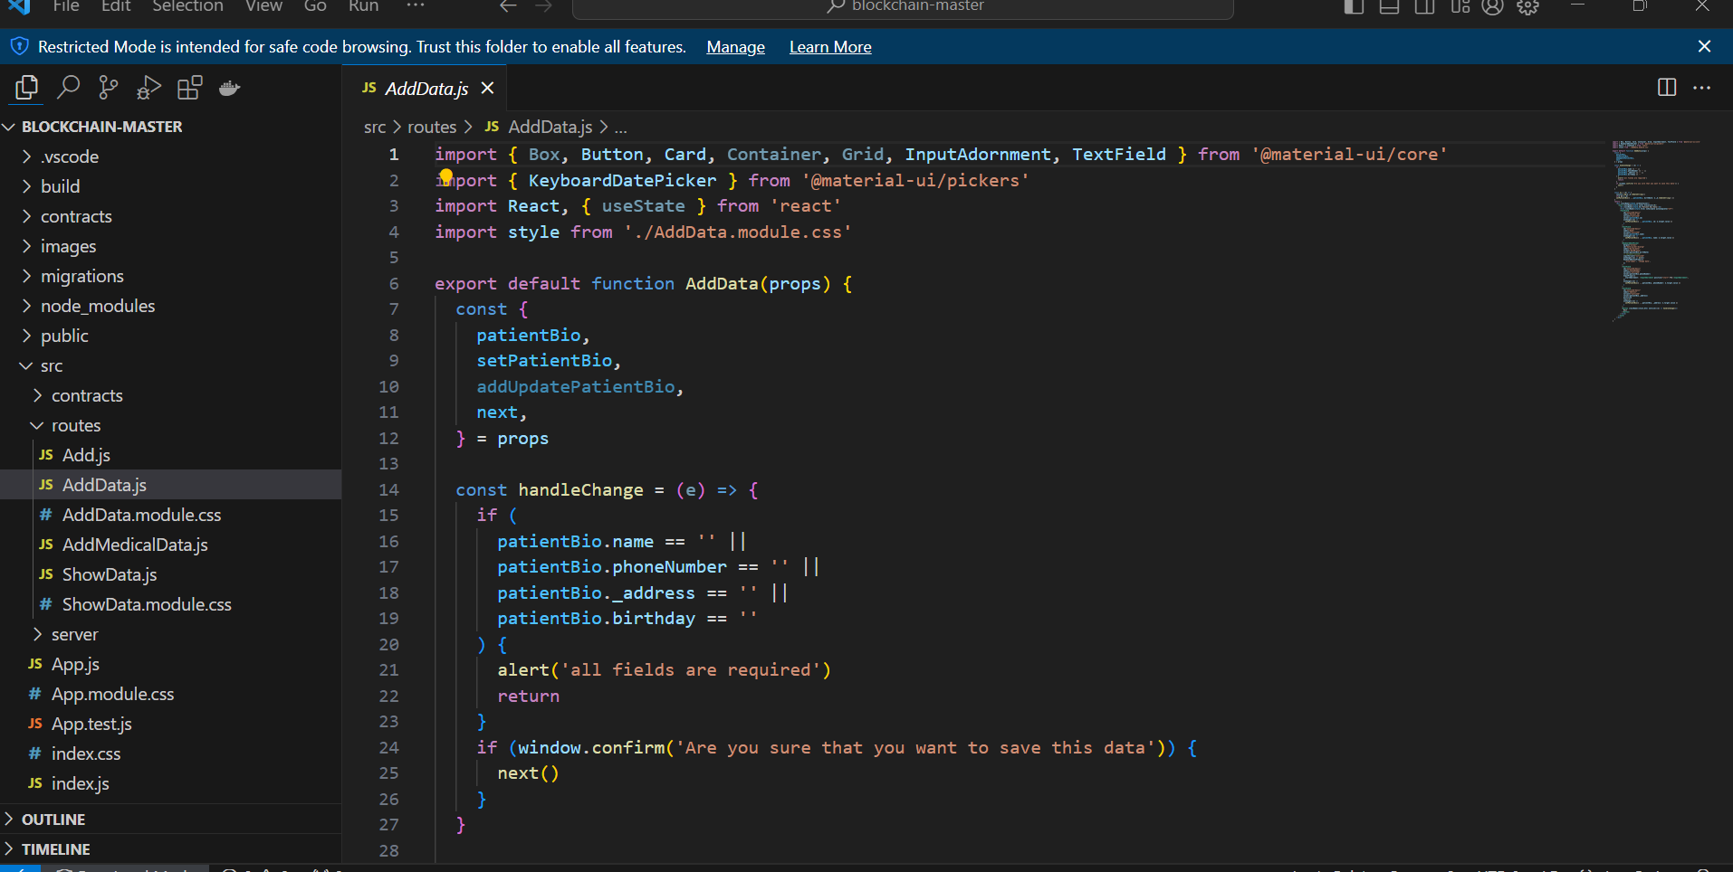

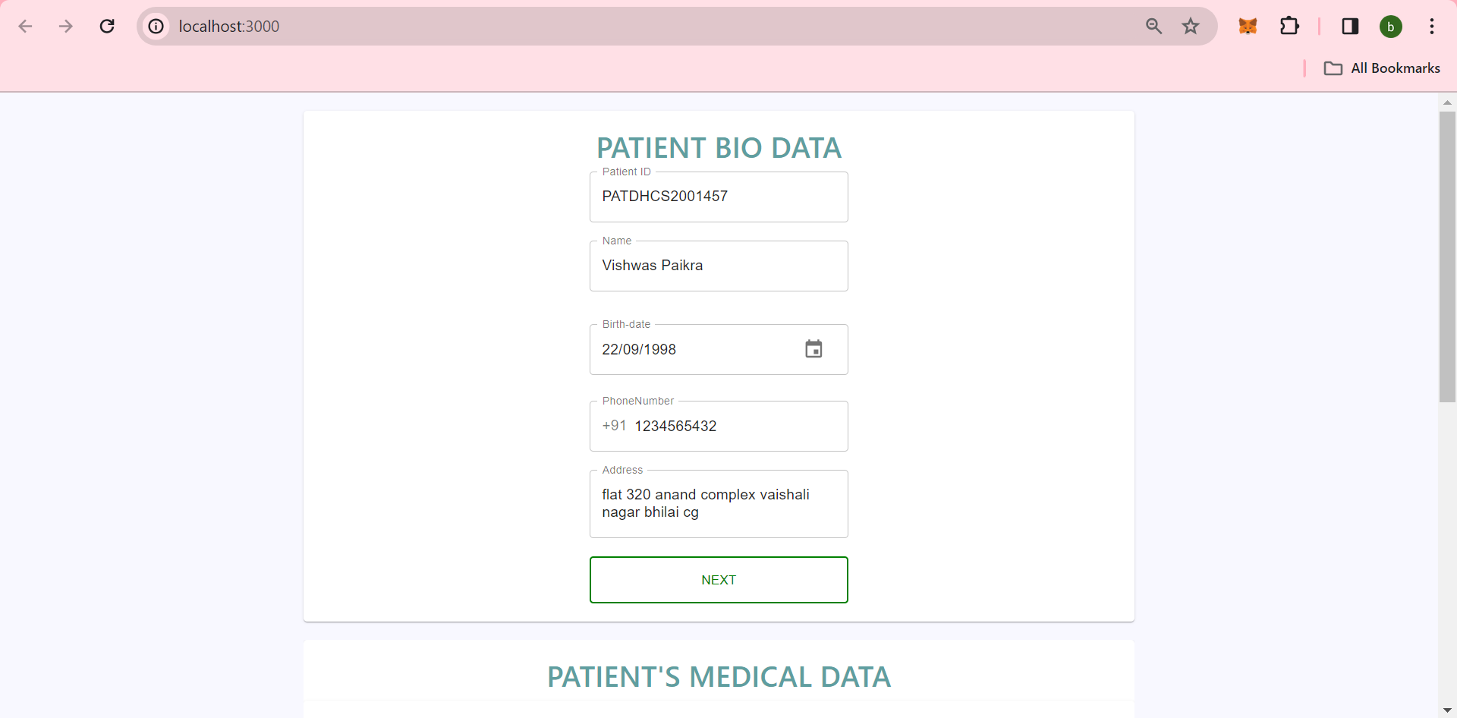

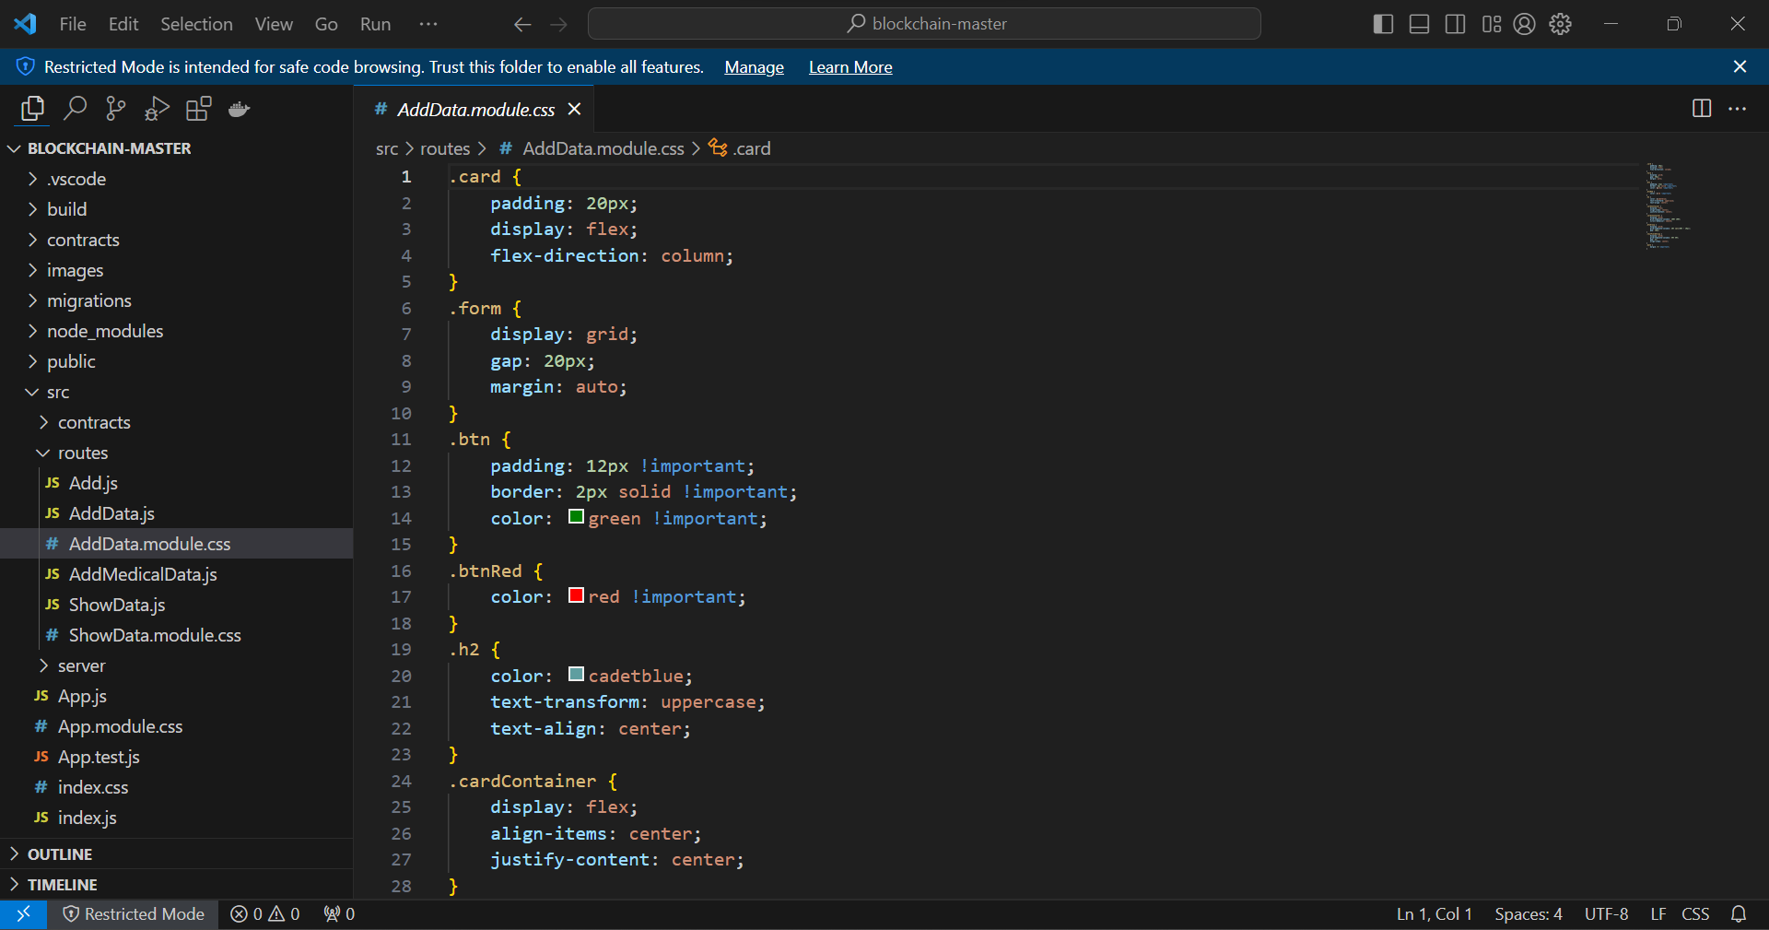

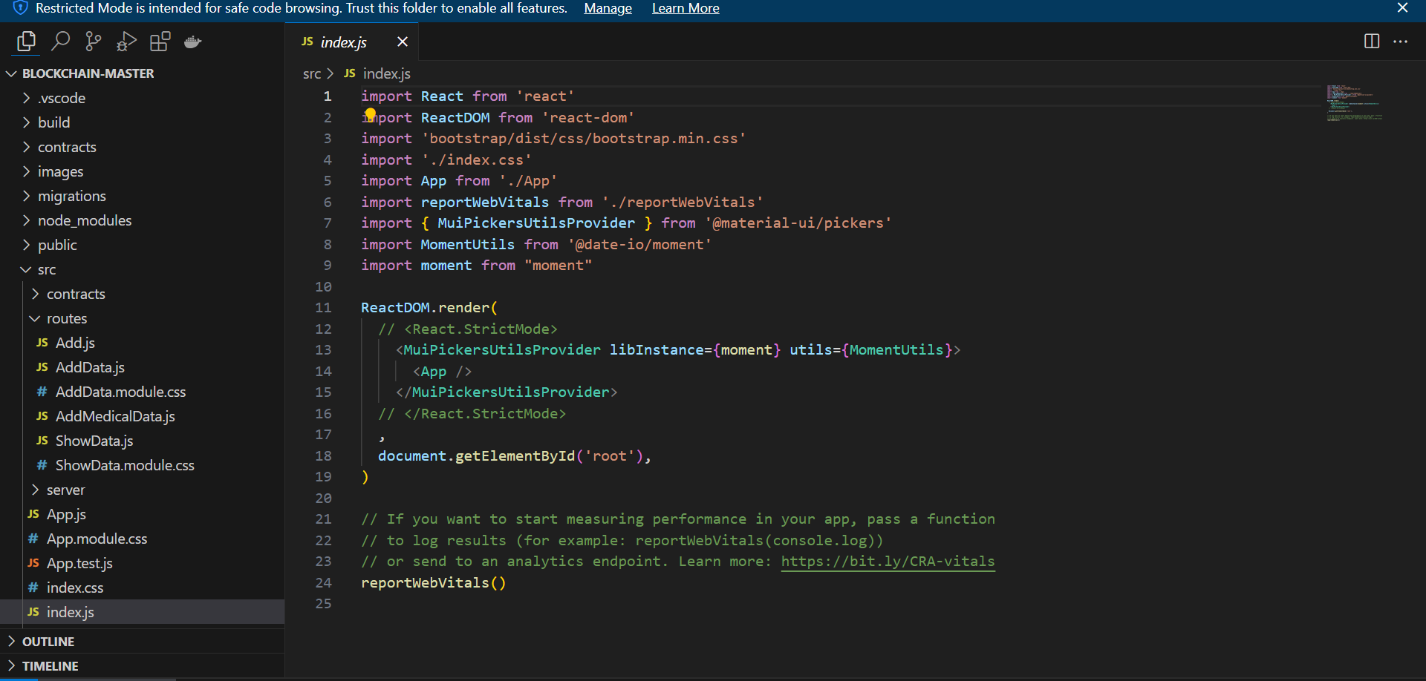

3. Encryption and Privacy Enhancements:

- Enhanced data encryption techniques were implemented to further secure sensitive patient information. Privacy policies have been defined and enforced to comply with regulatory requirements.

**Challenges Faced:**

1. Integration Challenges with Legacy Systems:

- Encountered some challenges during the integration with legacy healthcare systems. The team is actively collaborating with system administrators to address compatibility issues and ensure a smooth connection.

2. Refinement of Smart Contract Logic:

- Faced some complexities in refining the logic within the smart contracts to accommodate nuanced access control scenarios. Additional testing and collaboration with domain experts are underway to address this.

**Upcoming Goals:**

1. Integration of Smart Contracts for Data Access Control:

- Smart contracts governing data access needs to be integrated. This will allows us to automate and enforce rules for accessing and updating patient records based on predefined criteria.

2. Continued Testing and Quality Assurance:

- The upcoming week will focus on comprehensive testing and quality assurance activities to identify and address any potential security vulnerabilities and ensure the system's robustness.

3. User Interface Prototyping:

- We plan to initiate the prototyping phase for the user interfaces, aiming to create a user-friendly experience for healthcare providers, administrators, and patients interacting with the PDMS.

**Other Updates:**

1. Regular Team Collaboration:

- Our team continues to maintain effective collaboration through regular meetings and updates. This ensures that everyone is aligned with the project goals and contributes to a positive and productive work environment.